

**LAB RECORD**

23CSE111 – Object Oriented Programming

***Submitted by***

CH.SC.U4CSE24107– CHEEDELLA JYOTHIRMAI

**BACHELOR OF TECHNOLOGY**

IN

COMPUTER SCIENCE AND ENGINEERING

AMRITA VISHWA VIDYAPEETHAM

AMRITA SCHOOL OF COMPUTING

CHENNAI

## 

**AMRITA VISHWA VIDYAPEETHAM**

**AMRITA SCHOOL OF COMPUTING, CHENNAI**

**BONAFIDE CERTIFICATE**

This is to certify that the Lab Record work for 23CSE111- Object Oriented Programming Subject submitted by ***CH.SC.U4CSE24107 – CHEEDELLE JYOTHIRMAI*** in **“Computer Science and Engineering”** is a bonafide record of the work carried out under my guidance and supervision at Amrita School of Computing, Chennai.

|  |  |
| --- | --- |
| Internal Examiner 1 | Internal Examiner 2 |

# **Index**

|  |  |  |
| --- | --- | --- |
| **S.NO** | **Experiment Name** | **Page Number** |
| 1. | UML DIAGRAM | 5 |
|  | Library Management   * Class Diagram * Use Case Diagram * Sequence Diagram * State Activity Diagram * Object Diagram | 5 |
| 2. | Online Shopping   * Class Diagram * Use Case Diagram * Sequence Diagram * State Activity Diagram * Object Diagram | 9 |
| 3. | Basic Java Programs | 13 |
| i) | Even or Odd using an if-else statement. | 13 |
| ii) | Maximum of three numbers using if-else statements. | 14 |
| iii) | Calculator(Addition, subtraction, multiplication, and division ) | 15 |
| iv) | Fibonacci series | 16 |
| v) | Reverse a number | 17 |
| vi) | Factorial of a number | 18 |
| vii) | Prime Number Check | 19 |
| viii) | Palindrome Check | 20 |
| xi) | Armstrong Number | 21 |
| x) | Sum Of Natural Number | 22 |

UML DIAGRAM

1.Library Management:

1. Class Diagram:

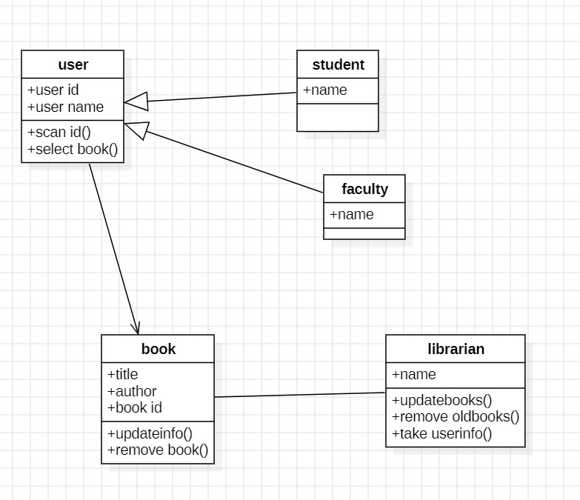

1. Use Case Diagram:

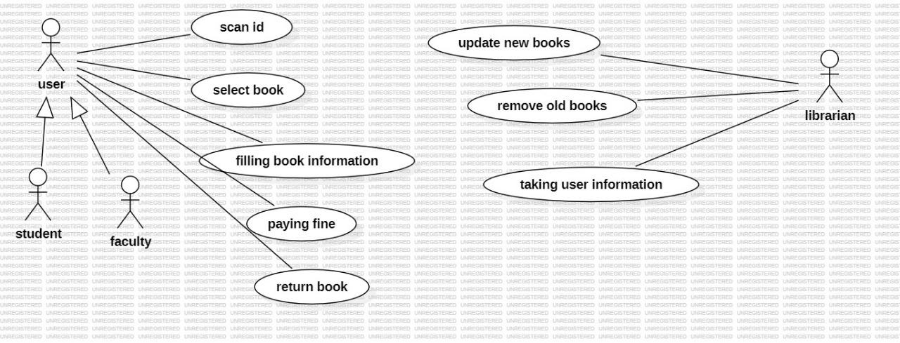

1. Sequence Diagram:

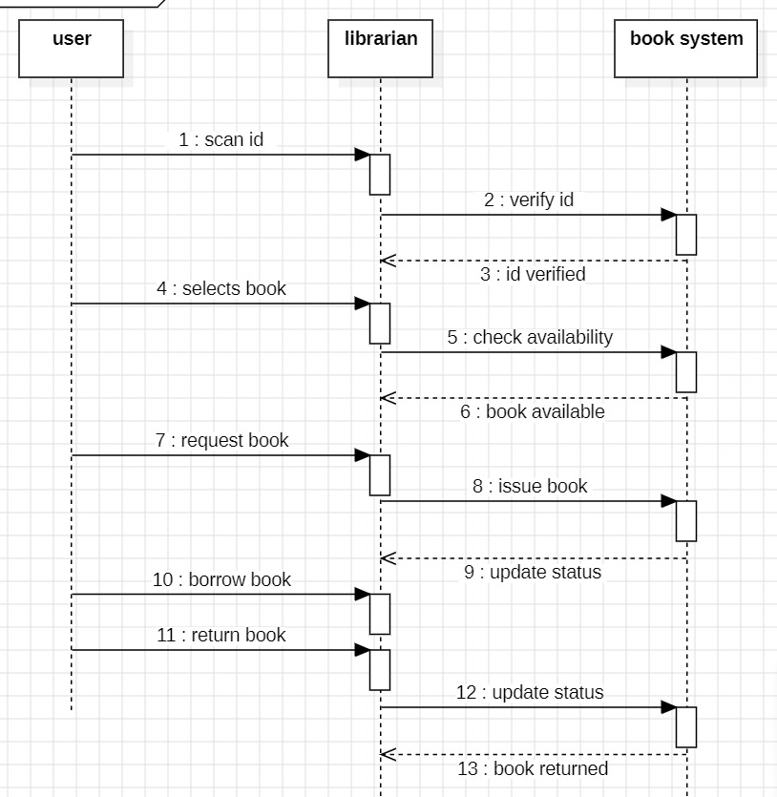

1. State Activity Diagram:

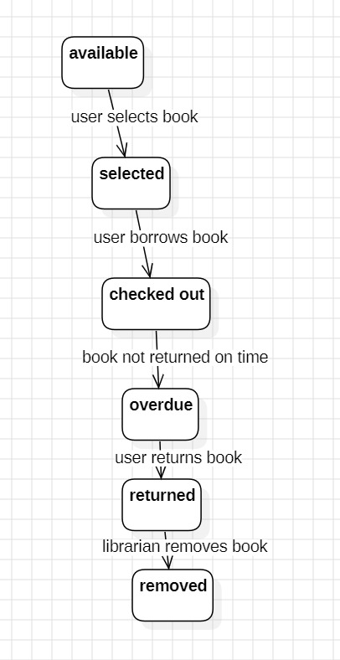

1. Object Diagram:

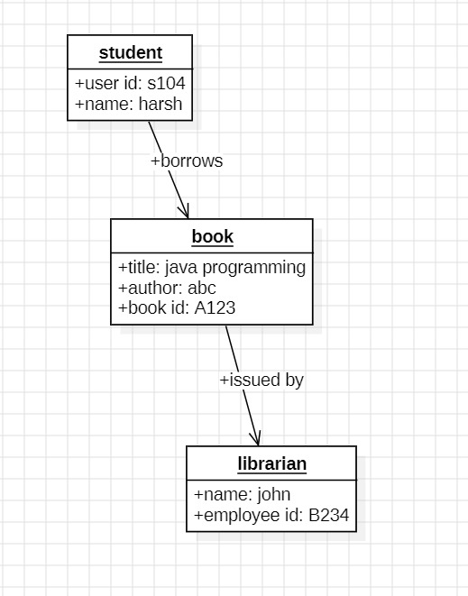

2.Online Shopping

1. Class Diagram:

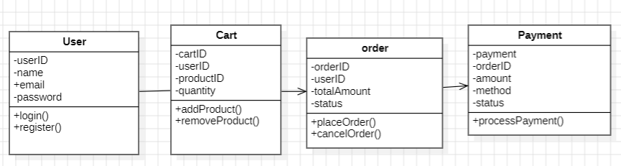

1. Use Case Diagram:

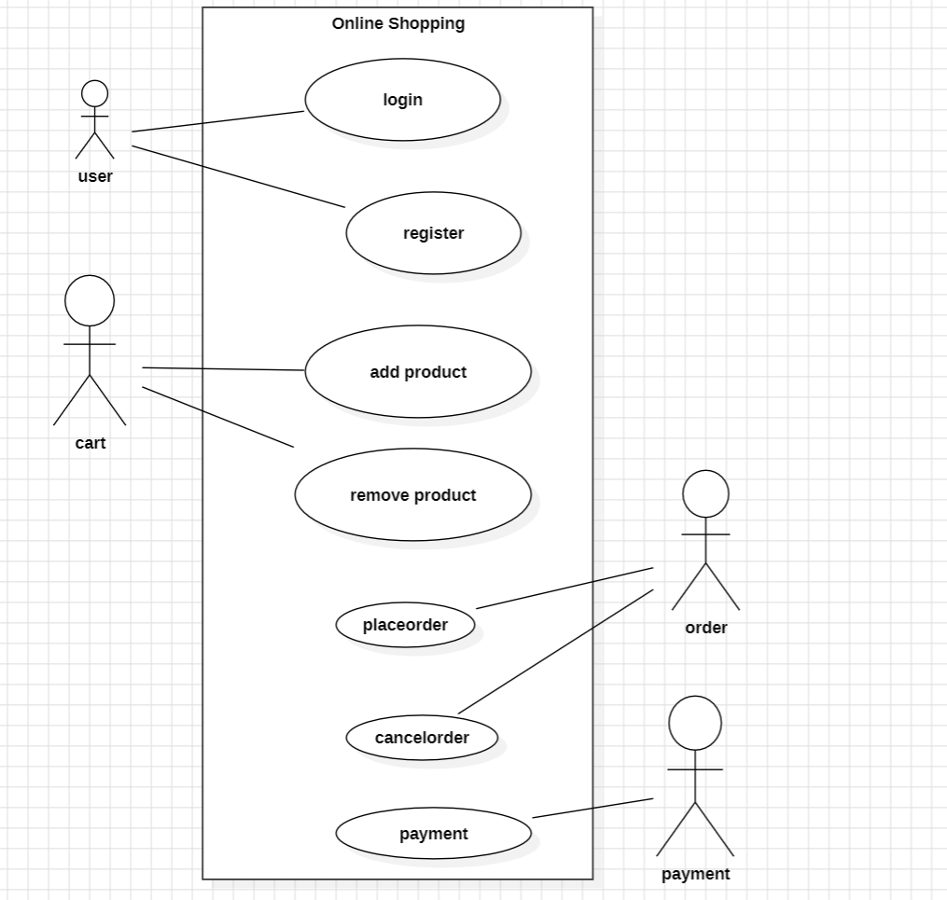

1. Sequence Diagram:

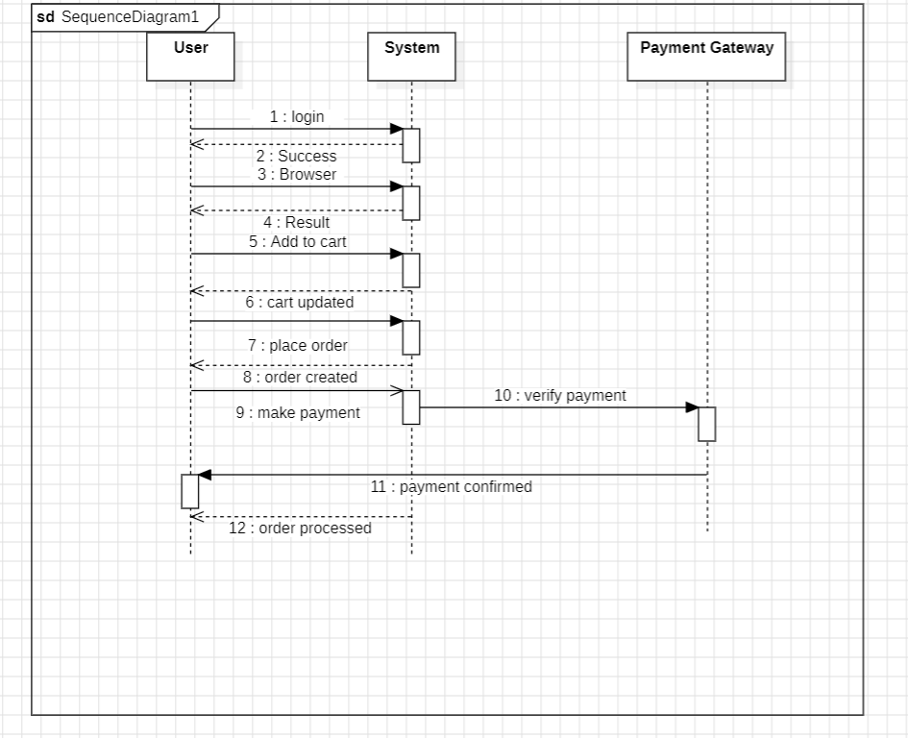

1. State Activity Diagram:

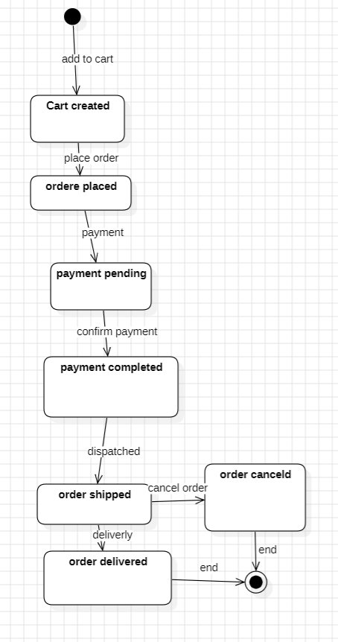

1. Object Diagram:

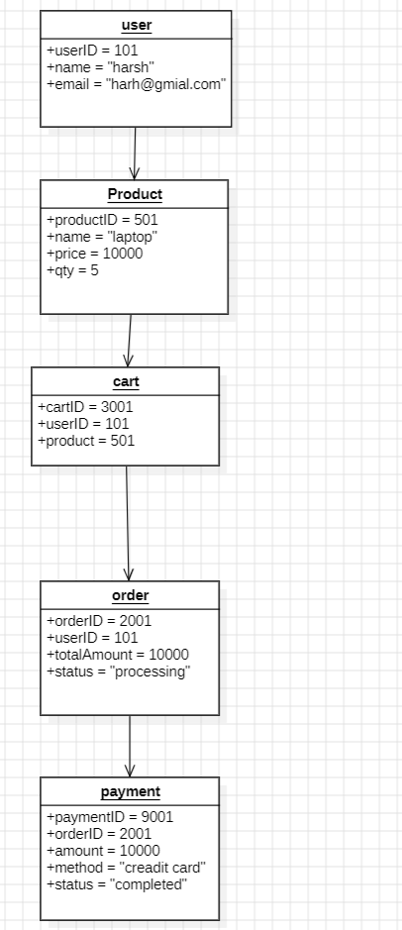

**Basic Java Programs**

1. Even or Odd:

Code:

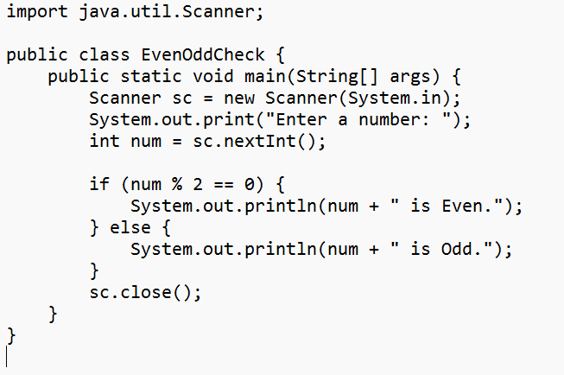

Output:

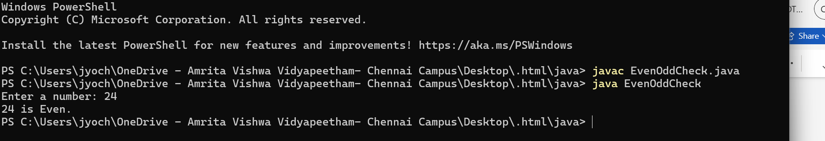

1. Max of 3 numbers:

Code:

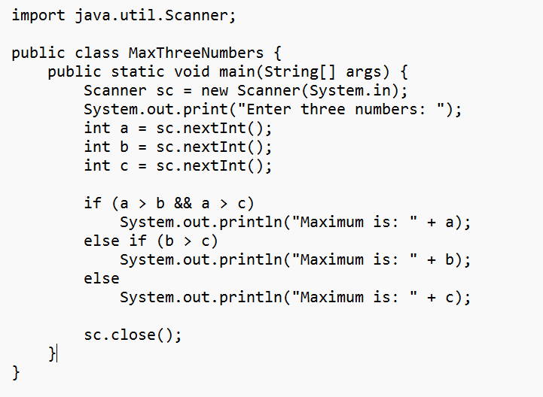

Output:

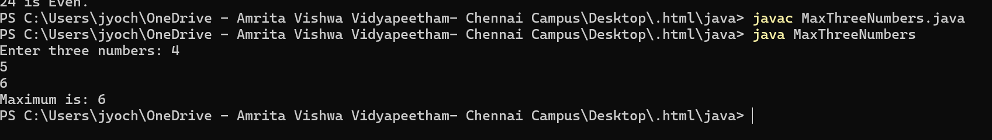

3.Calculator

Code:

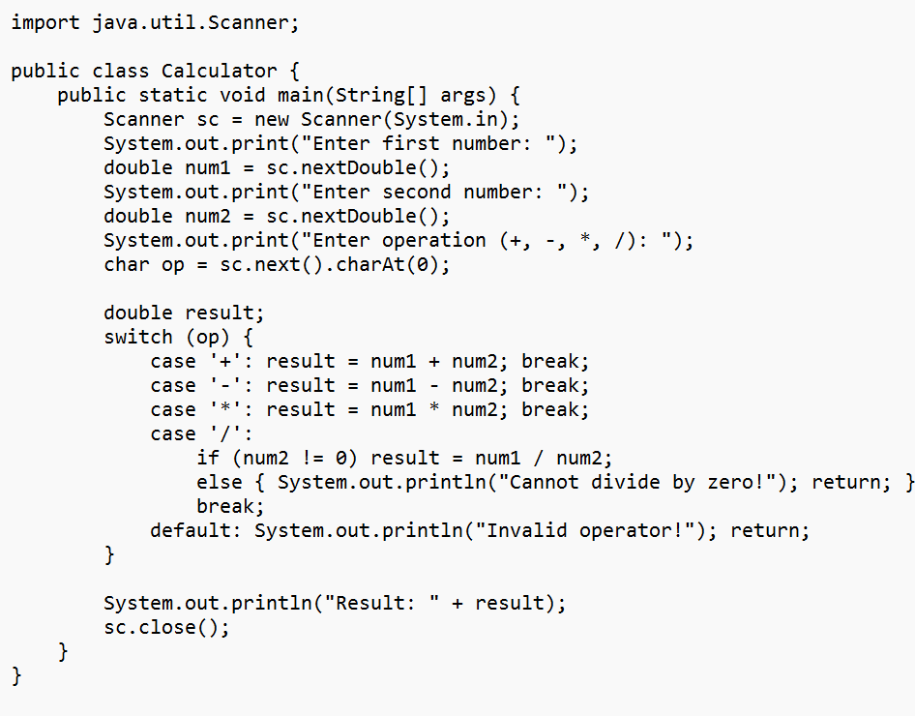

Output:

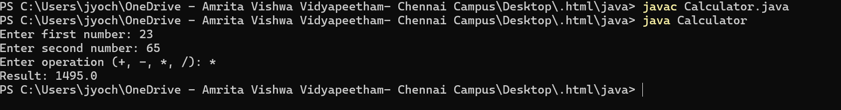

4.Fibonacci series:

Code:

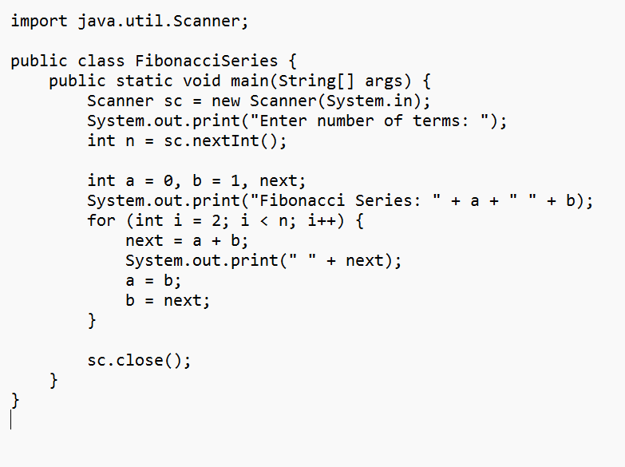

Output:



5.Reverse a number:

Code:

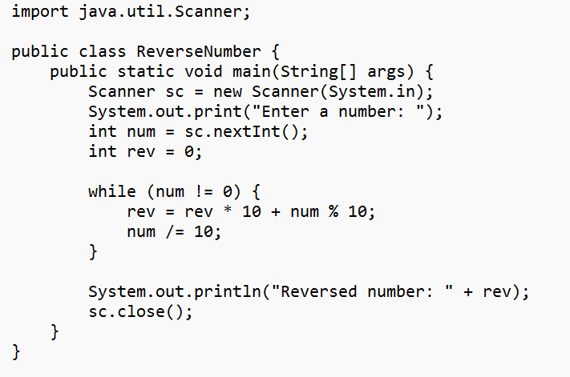

Output:



6.Factorial of a number:

Code:

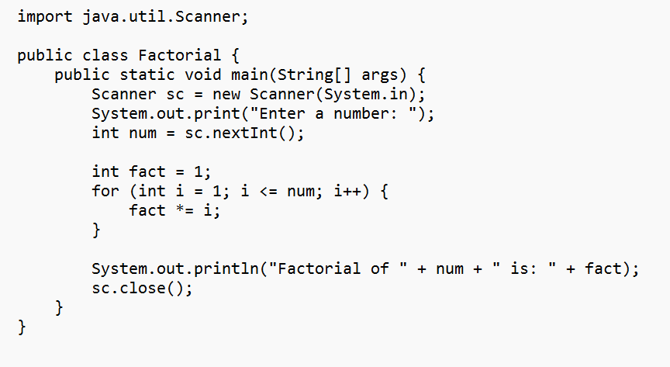

Output:



7.Prime Number Check:

Code:

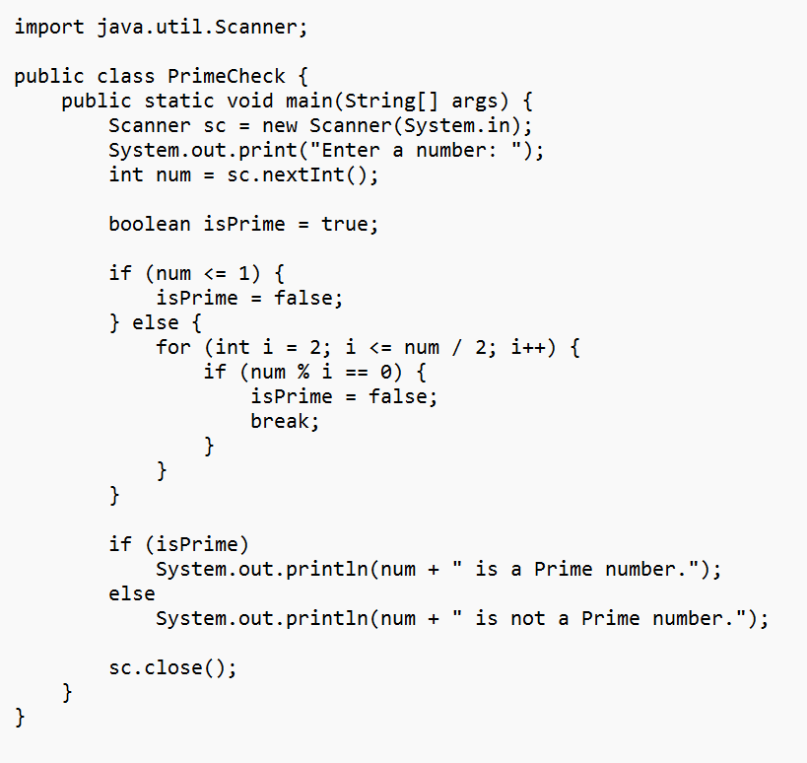

Output:



8.Palindrome Check:

Code:

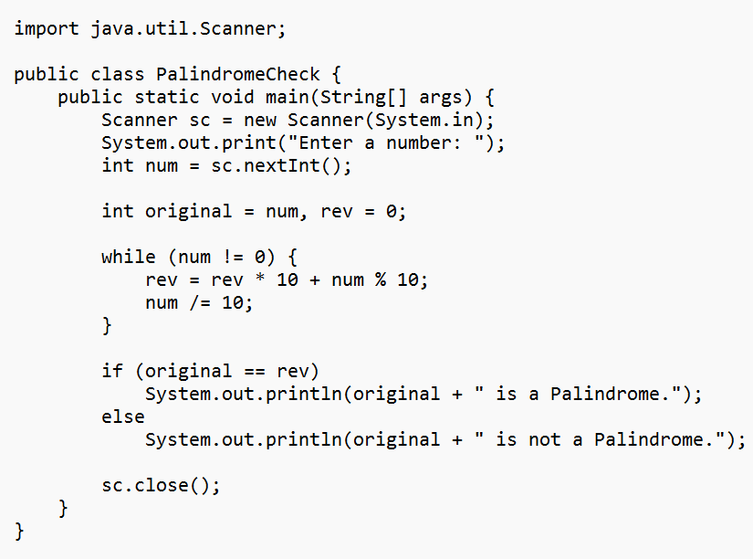

Output:

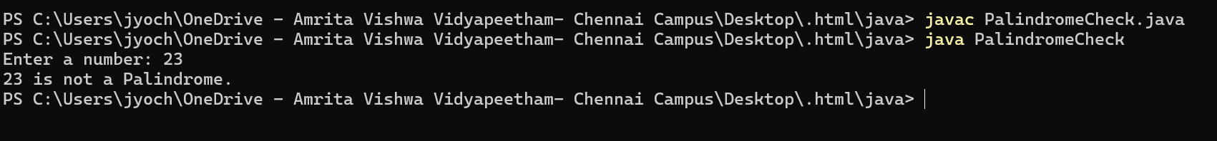

9.Armstrong Number:

Code:

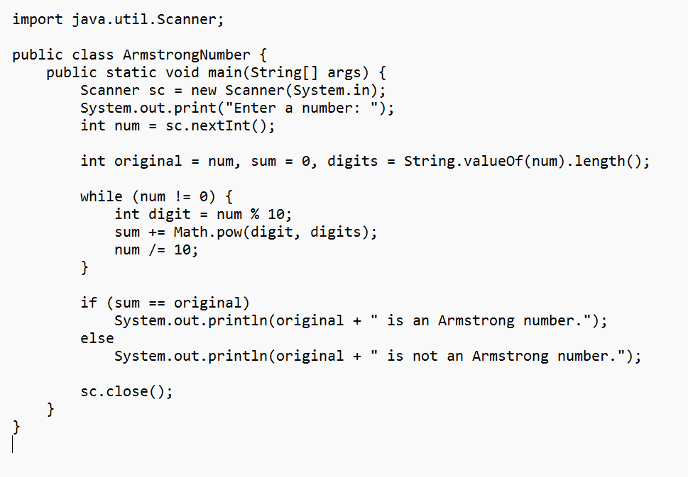

Output:



10.Sum of Natural Number:

Code:

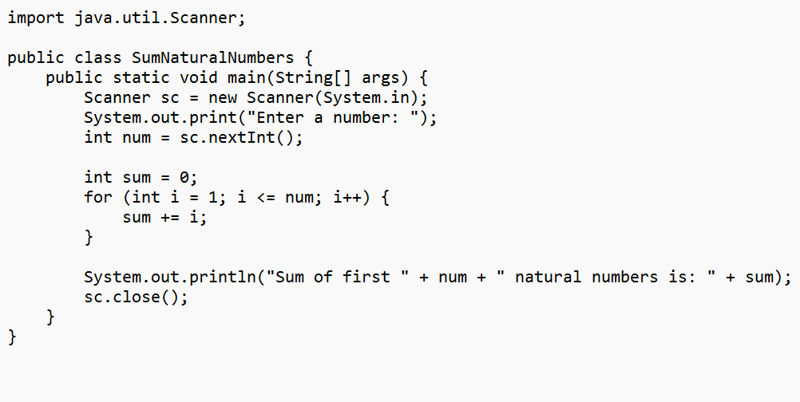

Output:

